Example: Implementing interfaces partially
REPORT Z1030OOPS36.
interface intf1.
methods : m1,
m2,
m3.
endinterface.
class lcl_impl DEFINITION ABSTRACT.
public SECTION.
interfaces intf1 ABSTRACT METHODS m2 m3.
endclass.
class lcl_impl IMPLEMENTATION.
method intf1~m1.
write :/ 'Inside method m1...'.
endmethod.
endclass.
class lcl_impl2 DEFINITION INHERITING FROM lcl_impl.
PUBLIC SECTION.
methods : intf1~m2 REDEFINITION,
intf1~m3 REDEFINITION.
endclass.
class lcl_impl2 IMPLEMENTATION.
method intf1~m2.
write :/ 'Inside method m2...'.
endmethod.
method intf1~m3.
write :/ 'Inside method m3...'.
endmethod.
endclass.
START-OF-SELECTION.
data ob type ref to lcl_impl2.
create object ob.
call method : ob->intf1~m1,
ob->intf1~m2,
ob->intf1~m3.
Example: Aliases for Local Interface components
REPORT Z1030OOPS37.
INTERFACE intf1.
methods : m1,
m2.
endinterface.
class lcl_impl DEFINITION.
public SECTION.
interfaces intf1.
aliases a1 for intf1~m1.
PROTECTED SECTION.
aliases a2 for intf1~m2.
endclass.
class lcl_impl IMPLEMENTATION.
* method intf1~m1. "(or)
method a1.
write :/ 'Inside method m1...'.
call method a2.
endmethod.
* method intf1~m2. "(or)
method a2.
write :/ 'Inside method m2...'.
endmethod.
endclass.
START-OF-SELECTION.
data ob type ref to lcl_impl.
create object ob.
call method ob->a1.
*call method ob->a2. "syntax error
Example: Including a local Interface inside another local Interface declaration
REPORT Z1030OOPS38.
interface intf1.
methods : m1,
m2.
endinterface.
interface intf2.
methods m3.
interfaces intf1.
endinterface.
class lcl_impl DEFINITION.
PUBLIC SECTION.
interfaces intf2.
endclass.
class lcl_impl IMPLEMENTATION.
method intf2~m3.
write :/ 'inside method m3 of intf2...'.
endmethod.
method intf1~m1.
write :/ 'inside method m1 of intf1...'.
endmethod.
method intf1~m2.
write :/ 'inside method m2 of intf1...'.
endmethod.
endclass.
START-OF-SELECTION.
data ob type ref to lcl_impl.
create object ob.
call method : ob->intf1~m1,
ob->intf1~m2,
ob->intf2~m3.
Example: Global aliases
Global Interface: z1030intf1
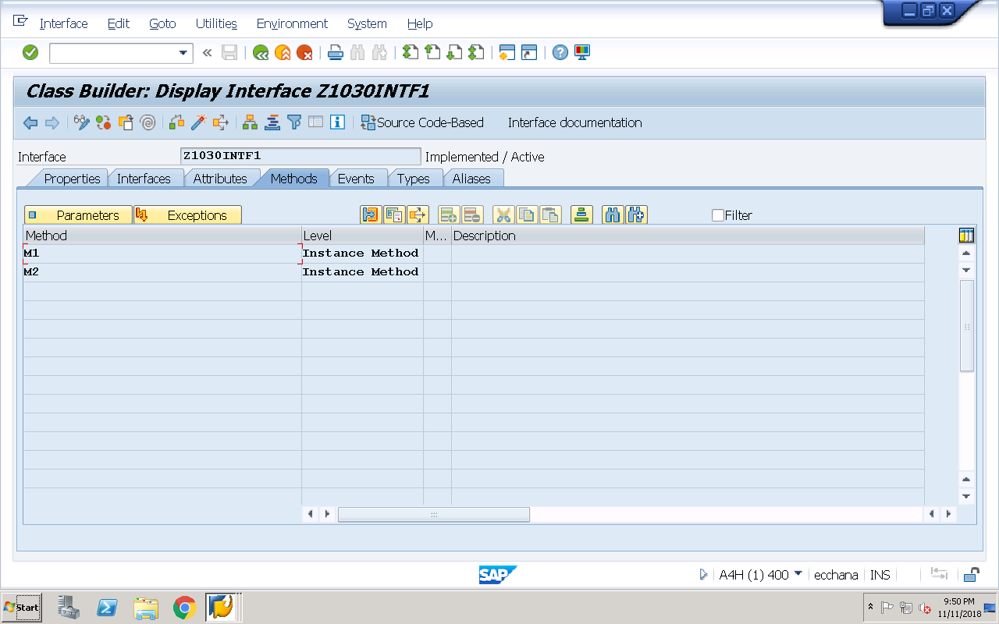
Global Implementation class implementing above global interface
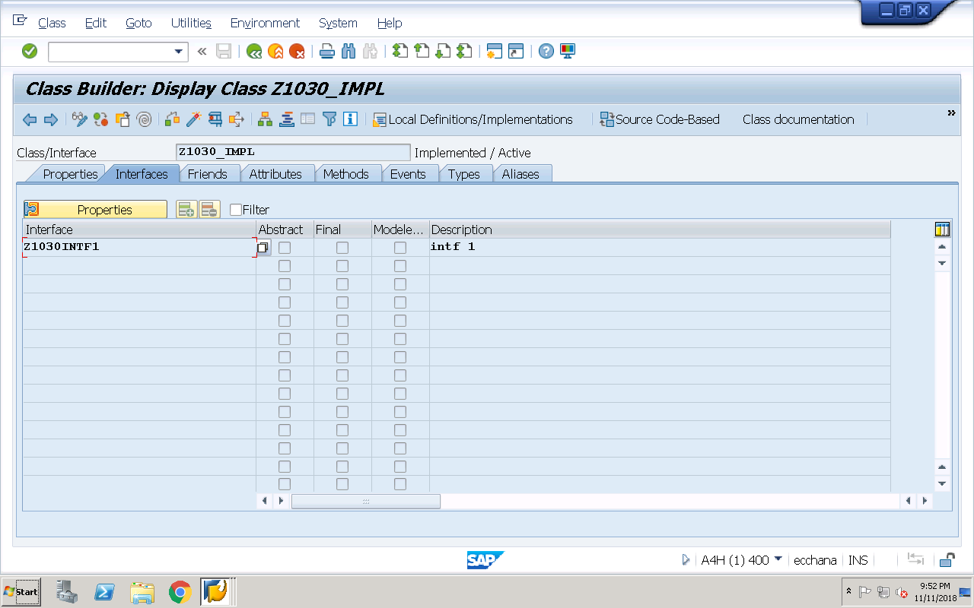
Global aliases for above global interface components
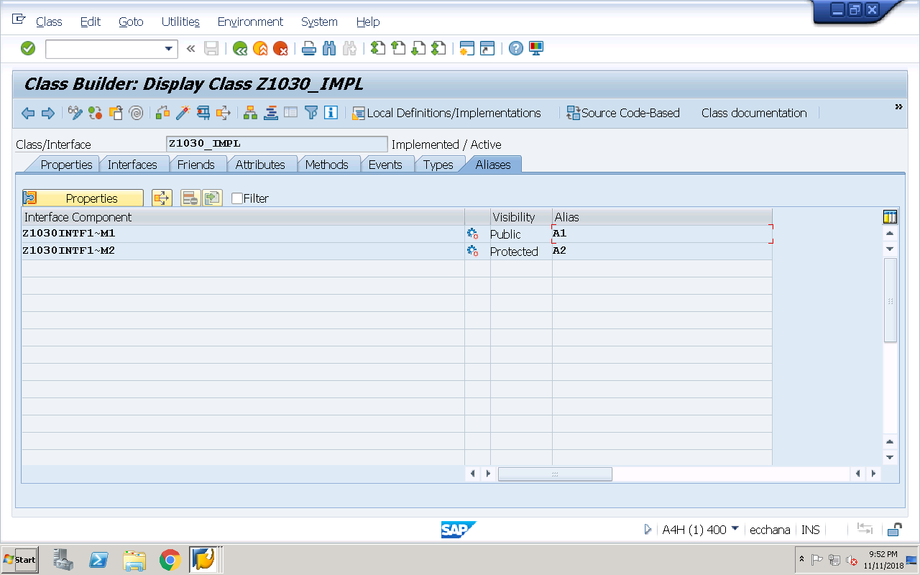

Implementation for above interface methods:
method Z1030INTF1~M1.
write :/ 'inside method m1...'.
call method a2.
endmethod.
method Z1030INTF1~M2.
write :/ 'inside method m2...'.
endmethod.
Executable program: For accessing above Global Aliases
REPORT Z1030OOPS39.
data ob type ref to z1030_impl.
create object ob.
call method ob->a1.
Example: Including Global interfaces inside other global interfaces
Global Interface 1: z1030_intf1
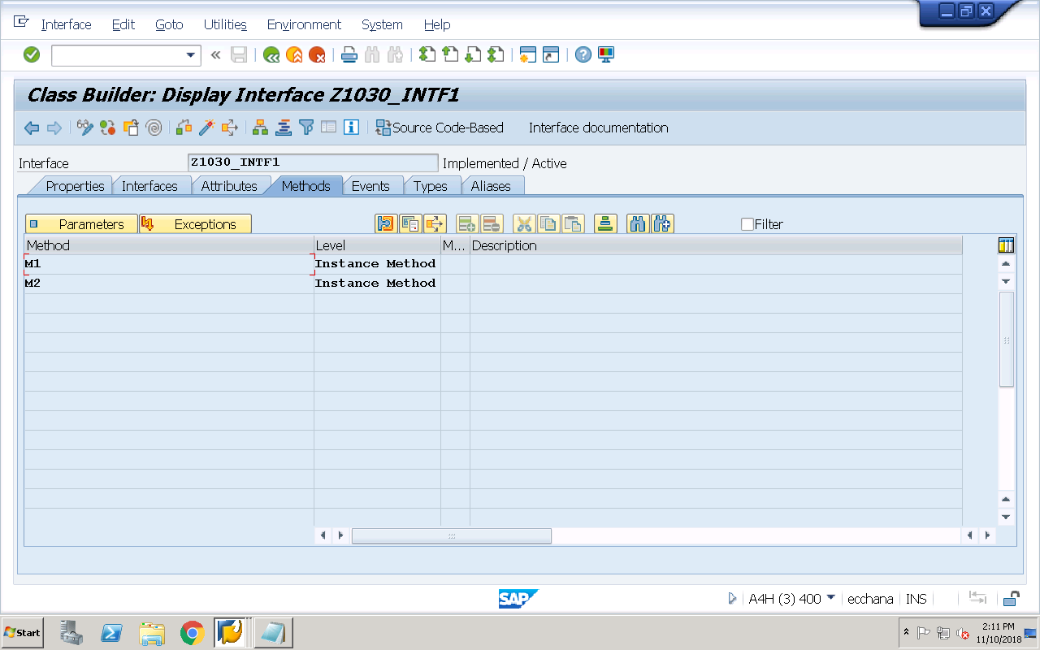

Global Interface 2 including other Global Interface 1

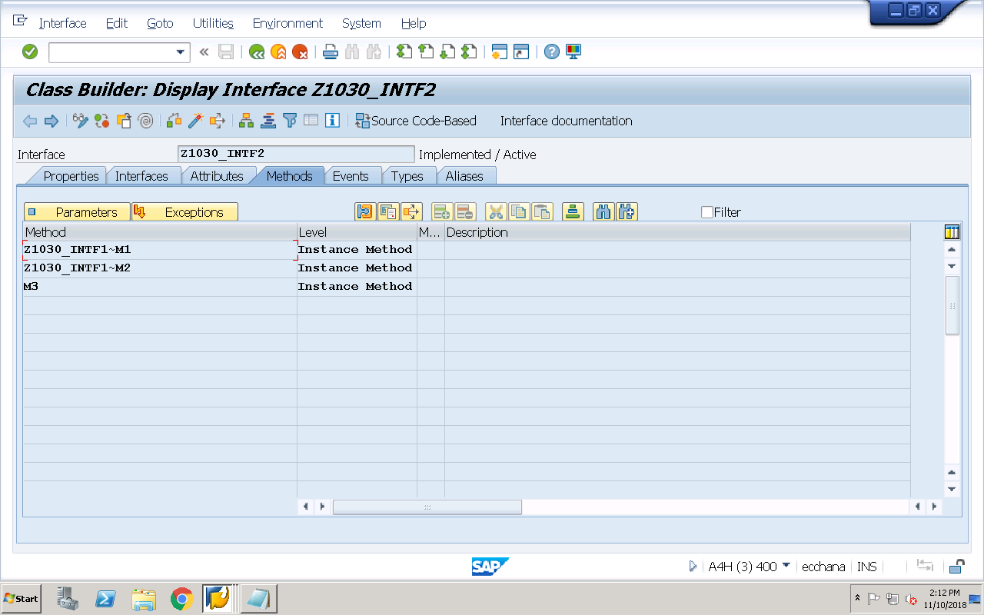
Implementaion class implementing Global Interface 2 (Automatically includes Global Interface 1)
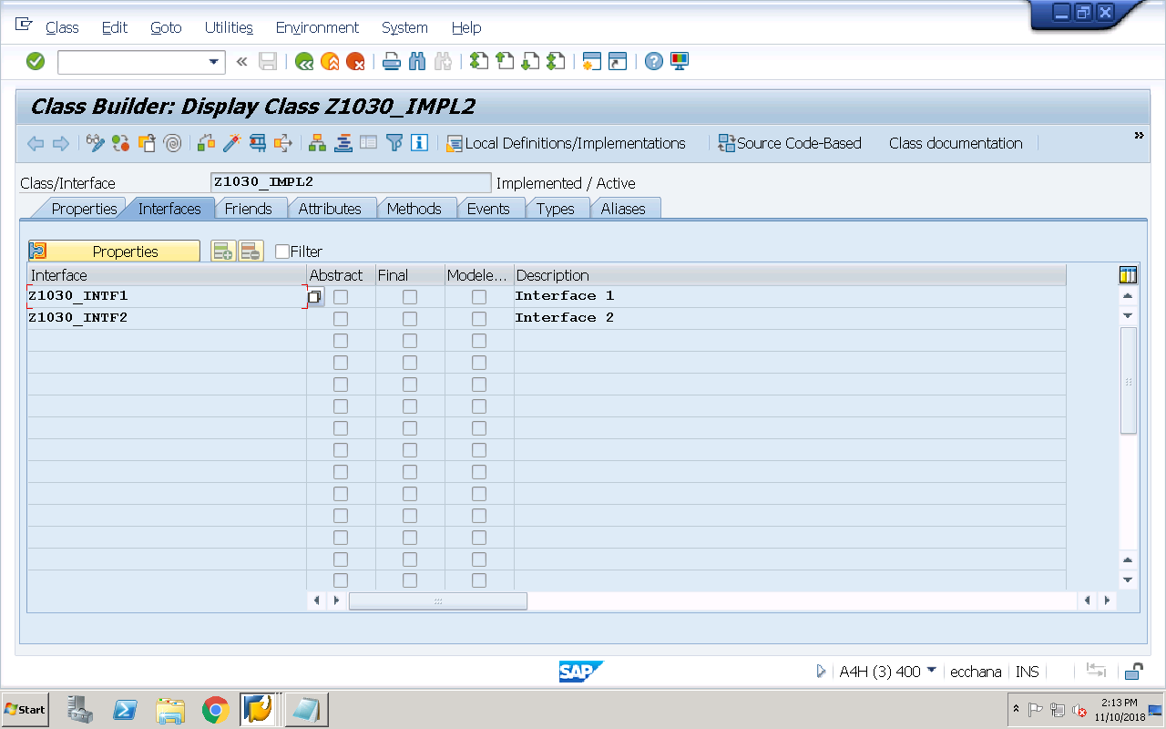
Implementation for both global interface methods:
method Z1030_INTF1~M1.
write :/ 'inside method m1 of intf1...'.
endmethod.
method Z1030_INTF1~M2.
write :/ 'inside method m2 of intf1...'.
endmethod.
method Z1030_INTF2~M3.
write :/ 'inside method m3 of intf2...'.
endmethod.

Global aliases for above 2 global interface components
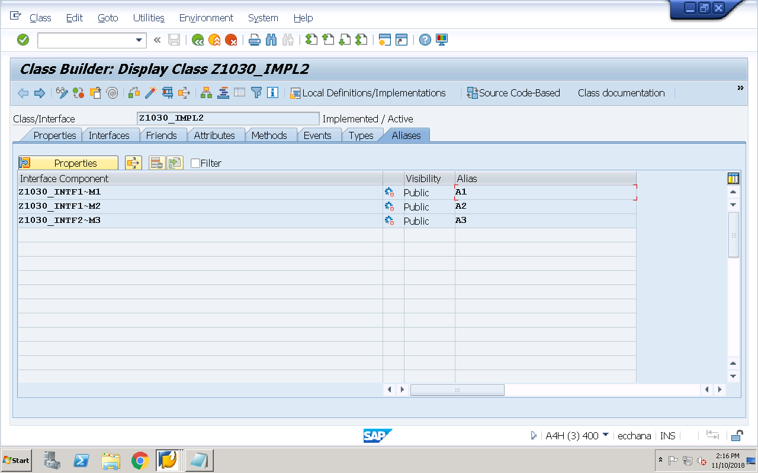
Executable program:
REPORT Z1030OOPS40.
data ob type ref to z1030_impl2.
create object ob.
call method : ob->a1,
ob->a2,
ob->a3.

